**Group members name and Roll No:**

**Rania(22k-4159)**

**Marium (22k-4320)**

**Aafreen(22k-4448)**

**Course Title: Programming Fundamentals(Lab)**

**Section: 1H**

**Project Topic: Checkers**

**Project Report**

Table of Content

Role and Contribution of each member2

Main idea of project2

Main feature of project2

Screenshot of code3

Problems encountered during project4

# Role and contribution of each member:

Rania: Code was Accumulated and Player 1, Player 2, and king conditions were identified by Rania.

Marium: Board was made by Marium.

Aafreen: Decision condition was identified by Aafreen.

Note: We discuss the project together and then we all three together identified the errors and problems that occurred during project.

# Main idea of project:

It is an interactive two multiplayer game. The main idea of checkers is to capture all of your opponent pieces. To start the game, the player with symbol ‘x’ goes first and the player with symbol ‘o’ goes second. Players can move their pieces only in diagonal direction. It has 8 rows and 8 columns, so the dimension of board is 8x8 with alphabets at its columns and number at its rows. Each player has 12 pieces. This game will continue till the pieces of one is completely disappeared and in the end of the game it will display the name of the winner.

# Main feature of project:

The main features of the project are:

1. Use of structure
2. Use of functions
3. Use of recursive function
4. Multiple decision conditions for every possible case.

# Screenshot:

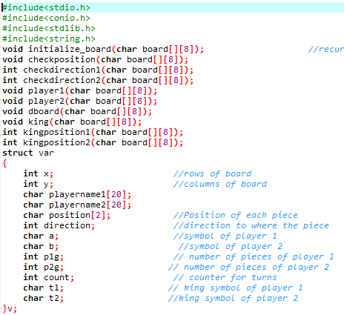

* Initialize board: This function is used to initialize the position of player 1 and player 2.
* dboard: This function is used to display the board.
* Checkposition: This function is used to check whether the pieces are chosen correctly.
* Checkdirection1: This function contains direction1 and direction 2 and it is used for player 1. Direction 1 shows the downward left movement of player1 and direction 2 shows the downward right movement of player 1.
* Checkdirrection2: This function contains direction3 and direction 4 and it is used for player 2. Direction 2 shows the upward left movement of player2 and direction 4 shows the upward right movement of player 1.
* Player1: This function is used to call the related functions according to player 1.
* Player2: This function is used to call the related functions according to player 1.
* King: This function is used to call the related functions according to king.
* Kingposition1: This function is used to call the direction 2

# Problems Encountered during project:

We faced many problems while compiling the code. The major ones are:

1. Semicolon, brackets and quotation issues.
2. We use graphic library to print the board but the library didn’t work properly.
3. While using nested decision condition.
4. Compiler wasn’t accepting values in char.
5. Figuring out the king moves according to the player1 and player2 functions. We use one function but that wasn’t working according to the king moves, so we use a different function for king itself.
6. We tried to use the player1 and player2 functions for the king but instead it was overloaded. Hence giving compiler issues.
7. Since we use a lot of recursive function and due to that we called wrong functions so it results in a big error.